PROJECT REPORT
Password Security Analyzer Pro
Project 1 — Defensive Logic Track
Industrial Training Kit, Batch 2026
Muhammad Zonorain (intern)
Submitted as part of the DecodeLabs Cyber Security Internship Program
Organization: DecodeLabs
Location: Greater Lucknow, India
Website: www.decodelabs.tech

1. Introduction
This report documents the design and implementation of Project 1 of the DecodeLabs Industrial Training Kit: a Password Strength Checker. The brief asked for a program that evaluates whether a password is weak, medium, or strong by checking its length and the variety of characters it uses. Rather than stopping at that minimum, this implementation was extended into a small but complete security-analysis tool, referred to here as "Password Security Analyzer Pro," that also estimates entropy, flags predictable patterns, and produces a numeric score with clear recommendations.
The purpose of the project, as stated in the training material, was not to teach "complex hacking" but to build a security mindset around data validation, string handling, and conditional logic — the same fundamentals that later support work on hashing, encryption, and authentication systems.

2. Objective
- Build a program that classifies a password as Weak, Medium, or Strong.
- Check password length and the presence of numbers, symbols, and uppercase letters.
- Go beyond the minimum brief by adding entropy estimation and pattern detection, so that a password with varied characters but a predictable structure (for example, Qwerty123!) is not misclassified as strong.
- Keep the validation logic O(n) — a single linear scan of the password — so performance stays predictable regardless of input length.
- Produce a codebase that is modular, tested, and documented well enough to explain and defend during review.

3. Tools and Technologies
Component | Choice | Reason
Language | Python 3.12 | Readable string handling, strong standard library for this task
Testing | pytest | Simple, widely used unit-testing framework
Structure | Modular .py files | Each concern (validation, entropy, scoring) is isolated and testable on its own
Version control | Git / GitHub-ready layout | Standard for showcasing a training portfolio

4. System Design
The program follows the Input → Process → Output model introduced in the training material. A raw password string is validated, scanned once for its character composition, scored against several independent criteria, and finally rendered as a readable report. Each stage is implemented as a separate module so that any one piece — for instance the scoring weights — can be changed without touching the others.

4.1 Input–Process–Output Model
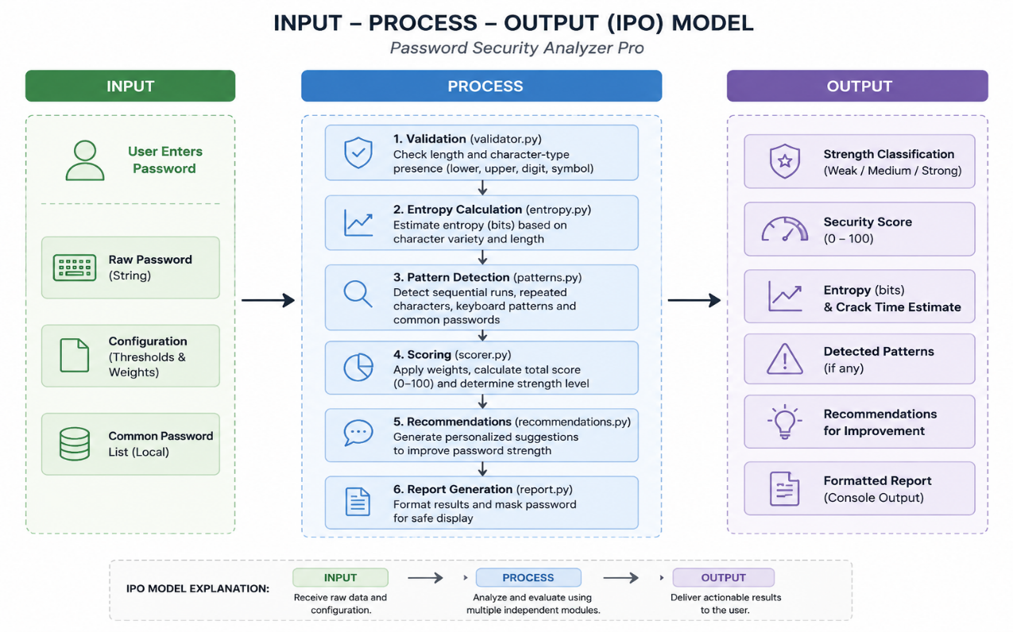
Figure 1: IPO model applied to the password analyzer.

4.2 Pipeline / Module Flow
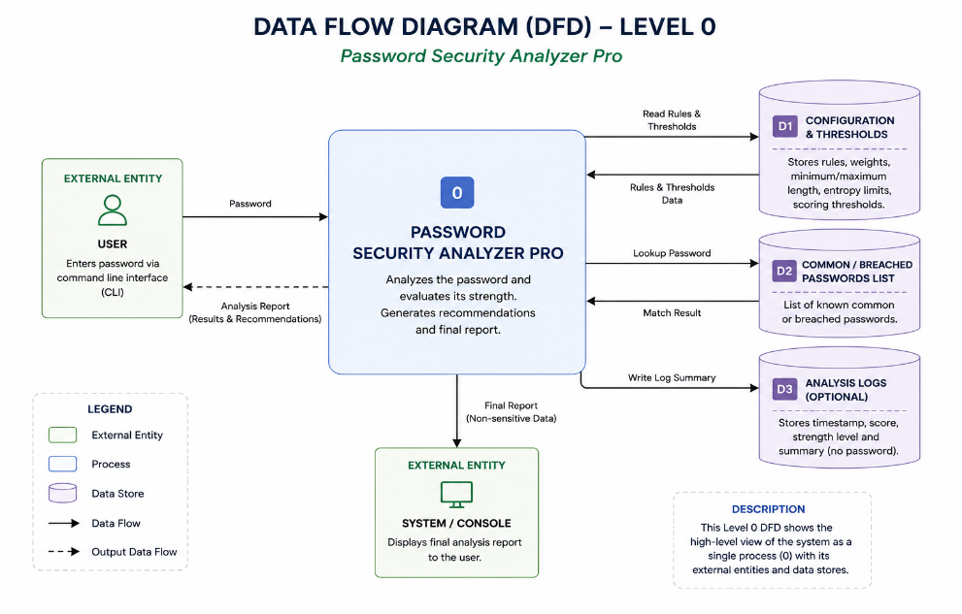
Figure 2: Data flow through the seven analyzer modules.

4.3 Module Responsibilities
Module | Responsibility
validator.py | Input sanity checks; detects length and presence of lower/upper/digit/symbol
entropy.py | Estimates entropy in bits and converts it to an approximate crack time
patterns.py | Detects sequential runs, repeated characters, keyboard walks, and common/breached passwords
scorer.py | Combines the above into a weighted 0-100 score and a strength label
recommendations.py | Converts findings into plain-language advice
report.py | Formats the final result for the terminal, masks the password for safe display
constants.py | Holds every threshold and weight in one place
utils.py | Small helpers, including a timing decorator
main.py | Entry point; wires the pipeline together and runs the CLI loop

5. Scoring Methodology
The final score is built from three positive components and one penalty, capped at 100 and floored at 0:
Component | Maximum points | Basis
Length | 25 | 0 points below 8 characters; full marks from 16 characters onward
Character variety | 25 | 6.25 points for each of lowercase, uppercase, digit, symbol present
Entropy | 25 | Scaled against a 60-bit ceiling using length x log2(pool size)
Pattern penalty | -25 | Deducted for sequences, repeats, keyboard walks; an automatic maximum penalty if the password matches a known common/breached password

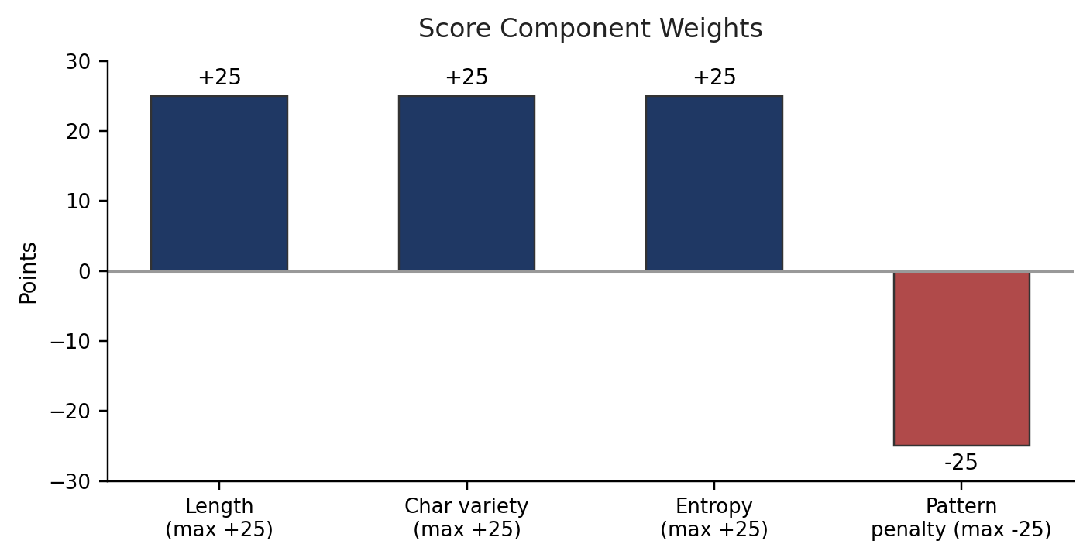
Figure 3: Maximum points contributed (or deducted) by each scoring component.
A password that appears in the common-password wordlist is always treated as a critical failure, because a password's real-world safety depends on whether it has already been leaked, not just on how random it looks in isolation.

6. Implementation Notes
Character detection uses Python's any() with a generator expression rather than a manual loop with a flag variable. This lets the built-in short-circuit as soon as a match is found and keeps the check to a single O(n) pass, which was one of the explicit constraints in the training material ("validation time must grow linearly, not exponentially").
Entropy is estimated using the standard formula bits = length × log2(pool size), where the pool size depends on which character classes are present. This is a simplification — it assumes each character was chosen independently at random — so it is deliberately paired with the pattern-detection module, which catches predictable, low-entropy-in-practice passwords that the formula alone would score too generously.
Passwords are never printed in full. The report module masks all but the first and last character before displaying anything, which mirrors how a real system should avoid echoing sensitive input back to a screen or log file.

6.1 Core Logic Screenshots
The screenshots below should show the key functions referenced in this section, taken directly from the editor (VS Code / PyCharm with line numbers visible is preferred).
validator.py — analyze_characters() 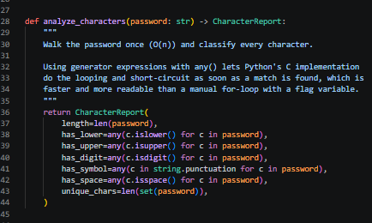

scorer.py — calculate_score() 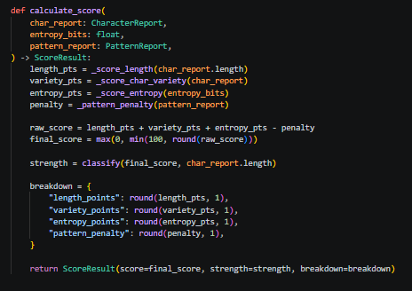

patterns.py — analyze_patterns() ] 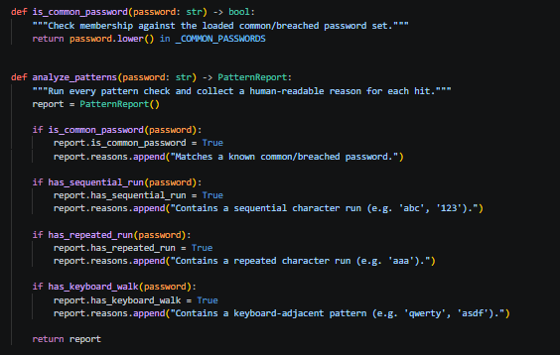

7. Testing
Twenty-one unit tests were written across three test files, covering the validator, entropy estimation, and pattern detection modules independently of the scoring and reporting layers. All tests pass under pytest.
Test file | Focus | Result
test_validator.py | Character-class detection, input validation edge cases | 8/8 passed
test_entropy.py | Pool size scaling, entropy growth with length, time formatting | 4/4 passed
test_patterns.py | Sequential, repeated, keyboard-walk, and common-password detection | 9/9 passed

Manual testing was also carried out with a range of sample passwords, from clearly weak (123456) to a long random passphrase, to confirm the scoring behaved sensibly across the full range rather than only at the extremes.

7.1 Test Case Summary
# | Input password | Expected rating | Reason
TC-01 | 123456 | Weak | Below minimum length, in common-password list
TC-02 | password1 | Weak | In common-password list, low variety
TC-03 | Qwerty123! | Weak / Medium | Good variety but keyboard-walk pattern detected
TC-04 | Tr0ub4dor&3XYZ | Strong | Good length, full variety, high entropy
TC-05 | correcthorsebatterystaple | Medium | Long but low character-class variety
TC-06 | "" (empty string) | Rejected | Fails input validation before scoring

7.2 Automated Test Run Screenshot
Run the following from the project root and capture the terminal output:
python -m pytest tests/ -v
pytest terminal output
Full terminal output showing all 21 tests passing (green PASSED lines). 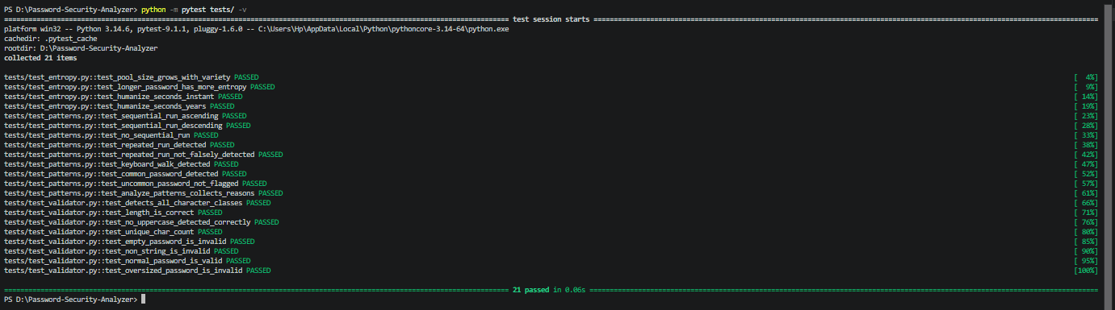

8. Sample Output
Example run for the password "Tr0ub4dor&3XYZ":
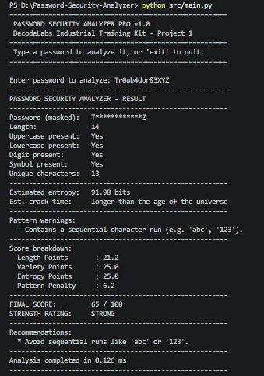

8.1 Program Run Screenshots
Capture the CLI running interactively (src/main.py) for at least one weak and one strong password, so both branches of the logic are visible in the report.
CLI run — weak password example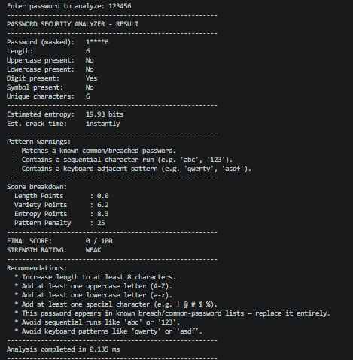
Terminal output for a weak password (e.g. 123456), showing the full breakdown and recommendations.

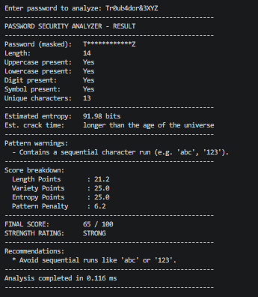
Terminal output for a strong password (e.g. Tr0ub4dor&3XYZ), showing the full breakdown.

9. Challenges Faced
- Balancing entropy math against real-world predictability — a purely mathematical entropy score rates patterns like "Qwerty123!" too highly, which is why pattern detection was added as a separate penalty rather than folded into the entropy formula.
- Keeping the character scan to a single linear pass while still checking four different character classes, solved by using any() with generators instead of nested loops.
- Deciding how harshly to penalize a common/breached password without letting it override every other signal, resolved by treating list membership as a capped but complete penalty rather than an outright score of zero.

10. Conclusion
This project satisfies the core requirement of Project 1 — checking password length and character variety and reporting a Weak/Medium/Strong result — while also building the surrounding logic (entropy, pattern detection, scoring, recommendations) that a real password-policy tool would need. Working through it reinforced the core idea from the training material: security tooling is, at its foundation, careful string handling and conditional logic applied consistently, before any cryptography enters the picture at all.
The codebase, tests, and this report are organized so the project can be extended directly into Project 2 (hashing and encryption) without restructuring — the validator module already acts as the "gatekeeper" that would sit in front of any password-hashing step.

11. References
- Verizon Data Breach Investigations Report (DBIR) — cited in the training material for the statistic that 81% of hacking-related breaches leverage weak or stolen passwords.
- Python 3 standard library documentation: string, math, dataclasses, functools.
- DecodeLabs Industrial Training Kit — Project 1 brief, Batch 2026.

